Answer 5
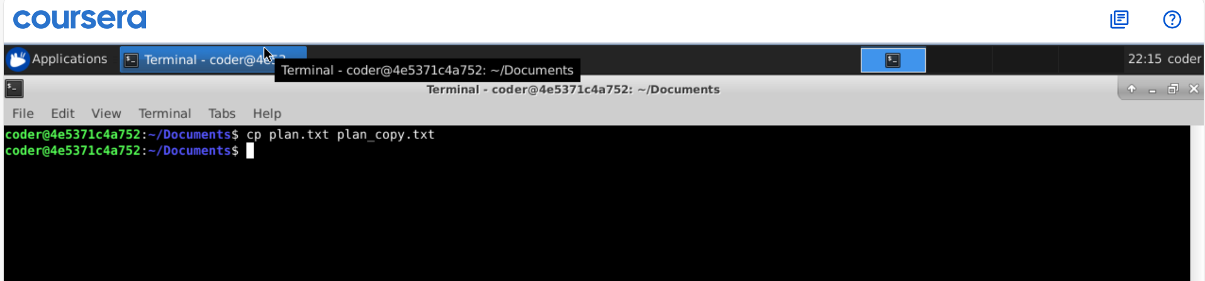
Explanation: By using cp command, we can copy a file. The syntax would be cp source_file new_file.

